1. Seasonal Patterns
   1. After generating our seasonal dummy variable and computing the regression of gcem on L(0/10) we have the following results seen in Figure 1. Using this we can then calculate the average value for gcem for every month to determine which has the largest and smallest average value seen in Figure 2. Using this we find that March has the largest average value with 0.2396536 and December has the smallest with a value of -0.3081064.
   2. Preforming the OLS of gcem on grres (x) and then with 1, 3, and 5 lags. The 3 regressions are seen in Figure 3. We can then find the three chi2 for each of these regressions in Figure 4. Using these we can calculate the nR2 for each of these regressions and compare them to the Chi2 to test for serial correlation which is seen in the following table.

|  |  |  |  |
| --- | --- | --- | --- |
|  | nR2 | Chi2 | Asymptotic Distribution |
| 1 Lag | 69.0844 | 69.237 | X^2(1) |
| 3 Lags | 101.9592 | 103.322 | X^2(3) |
| 5 Lags | 114.8512 | 117.311 | X^2(5) |

Based on this we see that the Stata reported Chi2 is close to our nR2 for all lags 1, 3, and 5.

* 1. Comparing Newey-West standard errors to our regular standard errors we see how the two models differ in Figure 5. As we can see the Newey west SE for grres is 0.408 and the normal regression SE is 0.376. Since there is serial correlation in the error terms the robust standard errors from our OLS regression are not consistent. This differs from our Newey-West SE which are consistent to order p since Newey-West standard errors account for the presence of serial correlation.
  2. Testing the null hypothesis that Beta1 equals Beta2 we find the T-test seen in Figure 6. Based on this we reject the null hypothesis in favour of the alternative hypothesis that Beta1 does not equal Beta2 with a 99% significance level.

Appendix:

Figure 1:

Figure 2:

Figure 3:

Figure 4:

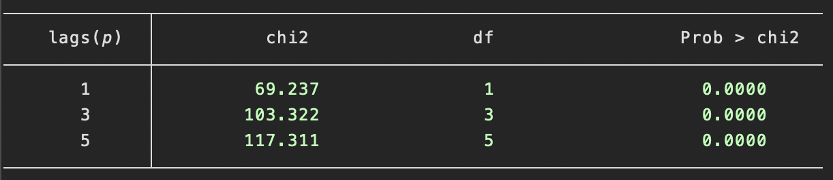

Figure 5:

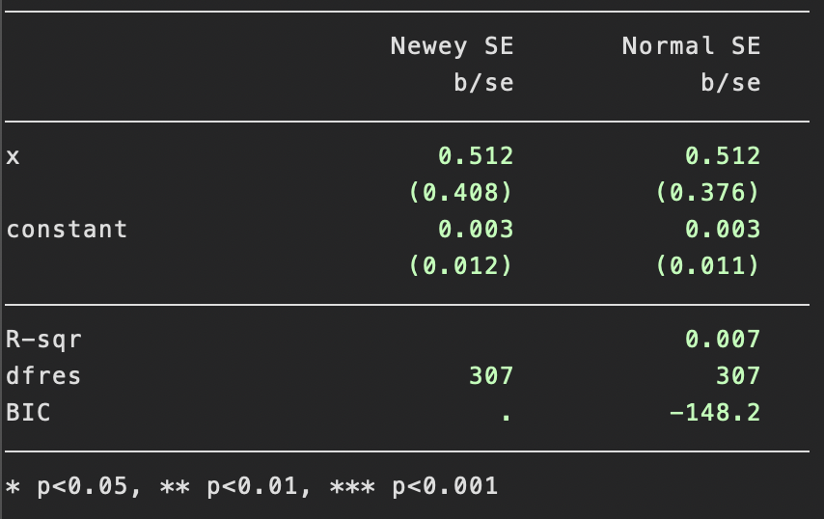

Figure 6:

